PB 2017-IP-02
SUPPLEMENTAL/BID BULLETIN

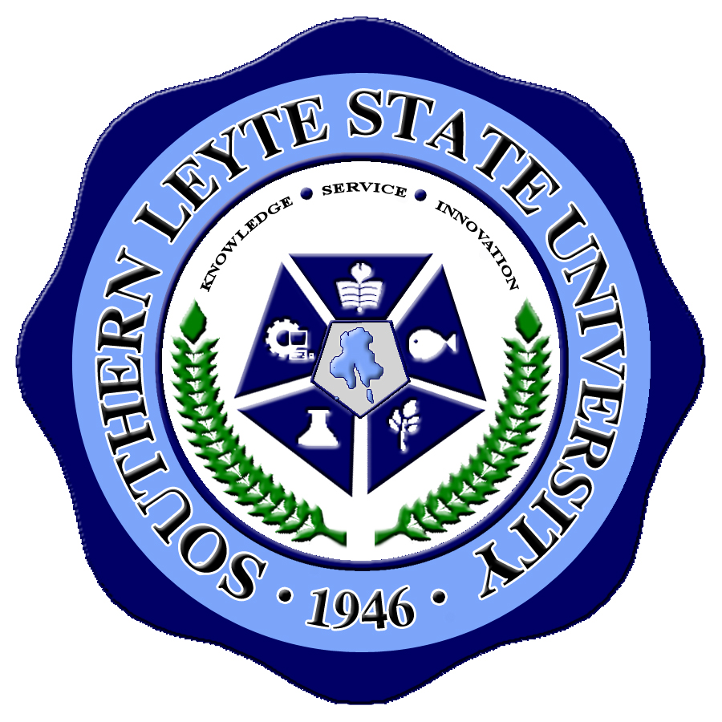
Republic of the Philippines
SOUTHERN LEYTE STATE UNIVERSITY
Sogod, Southern Leyte

Supplemental/Bid Bulletin No. 2

REHABILITATION OF ADMINSTRATION BUILDING, PHASE 1

POSTPONEMENT OF THE PRE-BID CONFERENCE

The Bids and Awards Committee announces that the Pre-bid Conference on Monday, October 16, 2017 for
the proposed project "Rehabilitation of Administration Building, Phase 1" is hereby rescheduled on Tuesday, October 17, 2017 at 1:30 pm, This is in line with the announcement made by Malacañang on Sunday, October 15, 2017 thru Executive Secretary Salvador Medialdea regarding the suspension of classes at all levels in public and private schools nationwide, as well work in government offices on Monday, October 16, 2017 due to the planned transport strike.

For your inquiries, you may coordinate with the Bids and Awards Committee Secretariat at Tel. No.
0956-549-0615.

Please be guided accordingly.

(Sgd.) VALERIO B. CABALO, Ph.D
BAC Chairman

